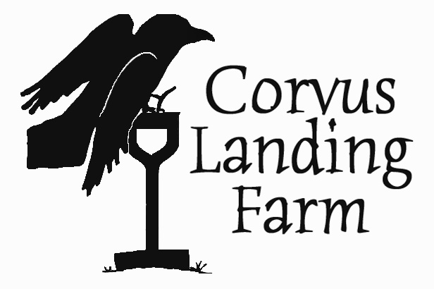
Job Title: Crew member
Type of position: Seasonal, part time
Compensation: $14+ per hour (DOE) plus produce. Camping on the farm available.
Open until filled.
Contact: Carolina Lees, carolina@corvuslanding.com (email preferred), 541-418-2281

Corvus Landing Farm is hiring 3 field workers for the 2022 season. The bulk of the work will be harvesting, washing, weeding, and trellising, but it will also involve a wide range of field work including planting, greenhouse work, seeding, and all aspects of plant and farm care. This is a small farm, and there’s always something going on! Employees may be asked to help with a diverse range of tasks needed to care for plants and keep the farm running smoothly.

We are also hiring for market and delivery help. Market employees will be responsible for set up and break down of the market booth, maintaining the market display throughout the day, and providing excellent customer service while selling farm products. Some market shifts require driving the farm delivery truck.

Market and field positions can be combined or separate.

Schedule
During the summer the crew works 4 days per week: M/T/W/F from 9 to 5:30. Hours are fewer in the spring and fall. Start dates are flexible and could be between April and June. We are looking for at least one person to start in April. The season slows down by the end of September, and we keep one person on until Thanksgiving.

Market and delivery help is on Thursdays and Saturdays from May to October. Saturday shifts can be scheduled on a rotating basis, with employees expected to work at least 3 Saturdays per month. Market shifts vary, but all end by 3:00 pm.

Requirements
Farm experience is not required for this position, and we will train the right person. Work can be repetitive and physically demanding, and we work outdoors in all conditions. But farming is also fun and rewarding, and you can’t beat the setting or the food. A positive attitude and open communication are a must.

This is also a good job for someone with a year or more of farming experience who wants to deepen their skills and work toward a farming career. Crewmembers will participate in a wide variety of farm tasks, giving you a range of farm experience. We are willing to spend time sharing our knowledge and systems, and we can help you learn how to run a successful small farm and connect you with other farmers in the region.

You must have reliable transportation or live on the farm. You must either live within commuting distance or be prepared to camp on the farm.

Applicants should be:
- Self motivated
- Conscientious and respectful
- Willing to take instruction
- Able to work independently
- Capable of working outdoors in adverse conditions (it rains a lot at the coast)
- Capable of doing full days of physical work
- Able to lift and carry 50 pounds
- Comfortable with numbers and basic arithmetic

Bonus skills and experience:
- Vegetable or flower farming experience preferred
- Other agricultural experience
- Customer service or retail experience, particularly in a farm, grocery, or food service setting
- Construction skills

Housing:
Housing opportunities in our area are limited. Applicants should already live within commuting distance, have housing lined up, or be prepared to camp on the farm. We provide one wall tent and wood stove, campfire ring, outhouse, shower, laundry, and places to charge batteries and fill up water containers. Partners, families, and pets will be considered on a case by case basis.

About the farm:
Now in its 13th season, Corvus Landing Farm is located in Neskowin, Oregon, 3 miles inland from the Pacific Ocean. We grow 2.5 acres of vegetables, fruit, and flowers for sale to the local community.

We use all natural methods to preserve and protect the health of our land and our neighbors. We specialize in crops that do well in our cool coast climate, particularly greens, roots, and flowers. We have young plantings of berries and tree fruit, and we grow veggie starts for coastal gardens. We sell our vegetables locally through 2 farmers markets, a 100-member CSA, an on site farm stand, and to select local businesses.

To apply:
Download and fill out our application form at corvuslanding.com/employment. Email it to carolina@corvuslanding.com, or mail to 8605 Slab Creek Road, Neskowin, OR 97149. You are welcome to attach a resume and cover letter if you like. Email or call Carolina Lees at 541-418-2281 with any questions.

