Job
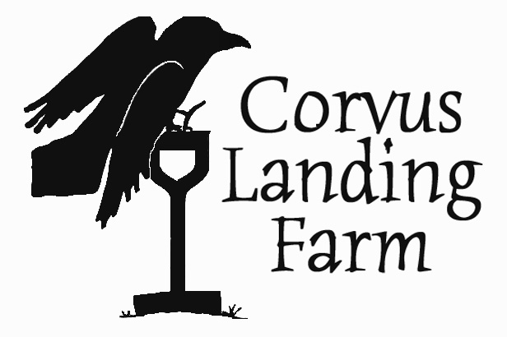
Application

Name: |  | Phone:
Email:
Address:
Do you have a valid drivers license? |  |  | [ ] Yes [ ] No
Do you possess reliable transportation? |  |  | [ ] Yes [ ] No
Are you eligible to work in the US? |  |  | [ ] Yes [ ] No
I am applying for ___Field ___ Market ___Both

Who were your three most recent employers and why did you leave?
1)Business Name |  | Supervisor Name
City, State |  | Business Phone | OK to call? [ ] Yes [ ] No
Reason for leaving
2)Business Name |  | Supervisor Name
City, State |  | Business Phone | OK to call? [ ] Yes [ ] No
Reason for leaving
3)Business Name |  | Supervisor Name
City, State |  | Business Phone | OK to call? [ ] Yes [ ] No
Reason for leaving

- What would make you a fantastic crewmember at Corvus Landing Farm?

- What do you think would be the most rewarding aspect of working at the farm?

- Do you have previous agricultural or horticultural experience? (Please include some details about each operation and your role there)

- Please describe any previous experience in retail or customer service.

- Please describe any physical limitations that might affect your ability to perform certain tasks. Market work involves heavy lifting (50 lbs.), working in all weather conditions, and bending and kneeling.

- We use a lot of numbers and basic arithmetic on the farm, as well as estimating proportions, weights, etc. Tell me about your comfort level with numbers and basic math.

- The coast does not have readily available housing. Do you already live locally, or are you ready to camp on the farm? Please describe how you envision your living situation this season.

- Is there any additional info you would like to share about yourself?

Please list 3 personal references not immediately related to you:
1) Name and Relationship |  | Email and/or Phone
2) Name and Relationship |  | Email and/or Phone
3) Name and Relationship |  | Email and/or Phone

