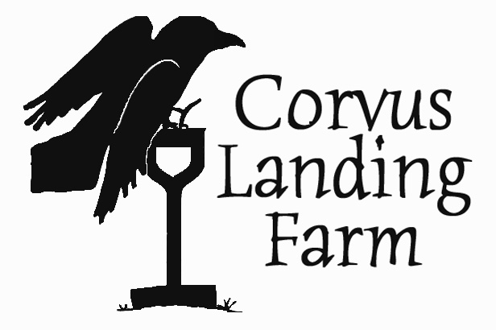

©2014 Corvus Landing Farm corvuslanding.com

**Corvus Landing Farm Recipes:**

**Get The Most Out of Your Vegetable Garden**

**Potting Mix**

**(for larger plants):**

* 1 pt compost
* 1 pt soil
* 1 pt Stutzman’s fluffy chicken manure
* 1 pt old potting soil
* 1.5 pt perlite
* Fertilizer mix (about ½ Tbsp per quart, recipe below)
* Lime: about 1 tsp per quart

**Sowing mix**

**(for seeds and young plants):**

* 3 parts coco peat, sifted
* 1 part Black Gold Worm Castings
* ½ part Black Gold Garden Compost
* 1 ½ parts perlite
* .05 parts fertilizer mix (about 1 Tbsp per quart, recipe below)
* Handful mycorrhizae

**Fertilizer for sowing mix:**

* 2 parts fish meal
* ¾ parts bone meal
* ½ part kelp meal
* ½ part azomite

**Steve Solomon’s Complete Organic Fertilizer (for garden beds):**

* 4 parts seed meal (or 2 parts fish or feather)
* ½ part lime (best is an equal mix of agricultural lime and dolomite)
* ½ part rock phosphate or bone meal
* ½ part kelp meal

Taken from *Growing Vegetables West of the Cascades*, Sasquatch Books, 2007