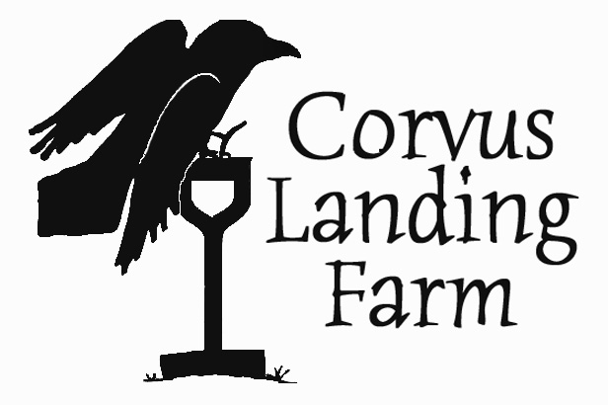
Job Title: Farmers market staff
Type of position: Seasonal, part time
Compensation: $14+ per hour (DOE) plus produce.
Open until filled.
Contact: Carolina Lees, carolina@corvuslanding.com (email preferred), 541-418-2281

Corvus Landing Farm is hiring 2 farmers market staffers for the 2022 season. Market employees are responsible for set up and break down of the market booth, maintaining the market display throughout the day, and providing excellent customer service while selling farm products.

Market staff may also be responsible for deliveries of farm produce. Some market shifts require driving the farm delivery truck. Market staff are required to follow the farm’s and market’s Covid-19 protocols.

We are also hiring crewmembers to work at the farm. Market and field positions can be combined or separate. Preference will be given to qualified applicants who are interested in filling both positions.

Schedule
The Neskowin Farmers Market is on Saturdays from 9 to 1 from May through September. We run a farm stand at the Lincoln City Hospital on Thursdays from May through October. Saturday shifts can be scheduled on a rotating basis, with employees expected to work at least 3 Saturdays per month. Market and delivery shifts vary, but all end by 3 pm.

Requirements
Customer service experience is preferred but not required. Market staffers should be able to multi task and be comfortable talking with a variety of people throughout the day. You must be familiar with using vegetables in the kitchen. Gardening or farming experience is helpful but not necessary.

You must have reliable transportation. Employees operating farm vehicles must have a valid drivers license and clean driving record. You must already live within commuting distance of the farm.

Applicants should be:
- Self motivated
- Familiar with using vegetables in the kitchen
- Conscientious and respectful
- Willing to take instruction
- Able to work independently
- Capable of working outdoors in adverse conditions
- Capable of doing full days of physical work
- Able to lift and carry 50 pounds
- Comfortable with numbers and basic arithmetic

Bonus skills and experience:
- Vegetable farming experience preferred
- Other agricultural experience
- Customer service or retail experience, particularly in a farm, grocery, or food service setting

About the farm:
Now in its 13th season, Corvus Landing Farm is located in Neskowin, Oregon, 3 miles inland from the Pacific Ocean. We grow 2.5 acres of vegetables, fruit, and flowers for sale to the local community.

We use all natural methods to preserve and protect the health of our land and our neighbors. We specialize in crops that do well in our cool coast climate, particularly greens, roots, and flowers. We have young plantings of berries and tree fruit, and we grow veggie starts for coastal gardens. We sell our vegetables locally through 2 farmers markets and a 100-member CSA.

To apply:
Download and fill out our application form at corvuslanding.com/employment. Email it to carolina@corvuslanding.com, or mail to 8605 Slab Creek Road, Neskowin, OR 97149. You are welcome to attach a resume and cover letter if you like. Email or call Carolina Lees at 541-418-2281 with any questions.

