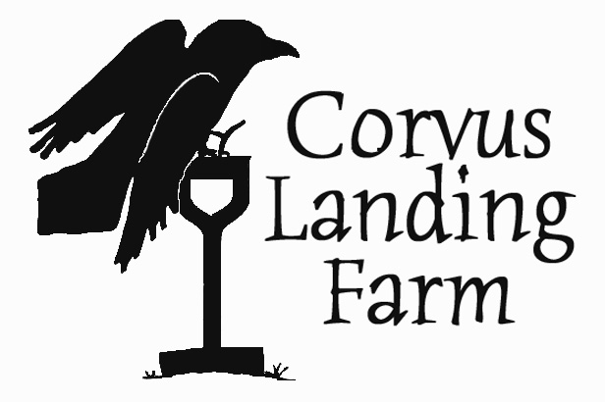
Recommended Resources: Get the Most From Your Vegetable Garden

We’re covering a lot today, but there’s always more to learn, and who can remember it all anyway? Here I’m listing a few resources that I’ve found helpful. There are hundreds more!

BOOKS:
Steve Solomon: Growing Vegetables West of the Cascades, Sasquatch Books.
Probably the best regional guide to growing vegetables.
Eliot Coleman: The New Organic Grower, Winter Gardening Handbook, and more.
These are written for more of a small farm scale, but have lots of useful information and innovative techniques.
Grace Gershuny and Joseph Smilley: The Soul of Soil.
Good primer on soil science and health.
Other authors: Carol Deppe, Michael Philips, John Jeavons, Joel Salatin. Acres USA is a great resource for finding and purchasing relevant books.

SEED COMPANIES:
Wild Garden Seed: Frank Morton breeds excellent seed for salads and more out of his farm
in Philomath
Adaptive Seeds: Sarah Kleeger and Andrew Still traveled to Europe to exchange and collect
seeds, and founded a seed company with what they brought back. Specializing in unusual varieties and cold-tolerant vegetables.
Fedco: A seed cooperative in Maine with an entertaining catalog, diverse seed sourcing, and
excellent prices
Johnny’s: Large seed company in Maine with excellent quality and selection and an
incredibly informative catalog and website.

SUPPLIES:
Dripworks has an informative catalog and website, lots of irrigation options, and also many
garden planning tools.
Peaceful Valley Garden Supply has all the supplies you need to grow organically and lots of
informative videos.
Naomi’s Organic Farm Supply in Portland has knowledgeable staff and a wide range of
well-researched products.
Concentrates in Portland is similar to Naomi’s.
TCCA Farm Store in Cloverdale and Tillamook carries several organic amendments and is
able to order many more.

ORGANIZATIONS:
OSU Extension and OSU Small Farms Program have lots of locally applicable online
resources. Also check out Washington State Extension.
Oregon Tilth has a long list of resources for organic farming and gardening at their website.
Mother Earth News has lots of good articles and resources.

